#### 

#### BS SOFTWARE ENGINEERING

#### 4TH SEMESTER

#### SOFTWARE DESIGN & ARCHITECTURE

#### PROJECT REPORT

#### BANK MANAGEMENT SYSTEM

#### SUBMITTED BY:

|  |  |
| --- | --- |
| RABIA LATIF | 20-SE-024 |
| M. AWAIS | 20-SE-001 |
| SYED HAIDER ZUBAIR | 20-SE-002 |
| USMAN ALI SHAH | 20-SE-016 |
| M USMAN | 20-SE-018 |

#### SUBMITTED TO:

#### SIR JUNIAD ALI KHAN

#### DEPARTMENT OF SOFTWARE ENGINEERING

#### HITEC UNIVERSITY TAXILA CANTT

2022

**BANK MANAGEMENT SYSTEM**

SOFTWARE DESIGN AND ARCHITECTURE

STUDENTS OF HITEC UNIVERSITY TAXILA CANTT

BS SOFTWARE ENGINEERING | 4 TH SEMESTER

**TABLE OF CONTENTS**

**ABSTRACT** 3

**INTRODUCTION** 4

PURPOSE 4

INTRODUCTION 4

IMPORTANCE OF E-BANKING 5

**SYSTEM FUNCTIONALITIES** 6

SYSTEM FUNCTIONALITIES 6

NON-FUNCTIONAL REQUIREMENTS 7

**ARCHITECTURAL STYLES** 8

“Service oriented architecture” of Bank Management System 8

“Layered architecture” of Bank Management System 9

**UML MODELING** 11

USE CASE DIAGRAM 11

ACTIVITY DIAGRAM 12

**SDA PRINCIPLES** 19

SDA principles 19

Problem partitioning 20

**IMPLEMENTATION** 22

**CODE** 22

**CONCLUSIONS** 39

CONCLUSIONS 39

REFRENCES 39

**GLOSSARY** 41

TERMS TO UNDERSTAND 41

ABBREVIATIONS 41

# **ABSTRACT**

The Bank Management System is an application for maintaining a person's account in a bank. This research work is based on **BANK MANAGEMENT SYSTEM** in which customers can access more accurate, quicker and rapid banking services from the bank management system. In this project we tried to show the working of a banking system and cover the basic functionality of the Bank Management System. Through bank management system, a client can acquire his record and manage numerous exchanges utilizing his cell phone or personal computer.

The main aim of this project is to develop software for Bank Management System. This project has been developed to carry out the processes easily and quickly, which is not possible with the manuals systems, which are overcome by this software. This system will help to solve problems by making transactions easier through mobile or any computerized system & many more. Thus, features of this project will save transaction time and therefore increase the efficiency of the system.

**CHAPTER 1**

# **INTRODUCTION**

## PURPOSE

Purpose of making this project is making our semester project “**Software Design and Architecture”**. The main aim of this project is that we have to choose a system of our own choice and display all its architectural styles and also do its implementation in **java** programming language and also do its software modeling .

## INTRODUCTION

Bank management system is use of computers and telecommunications to enable banking transactions to be done by telephone or computer rather than through human interaction. Its features include creating account, checking balance, deposit money , withdraw money and view transaction history . Electronic banking has vastly reduced the physical transfer of paper money from one place to another or even from one person to another.

In banking systems all work is done virtually rather than manually. It helps the user to work easily from home and it takes less time. Now a day’s, managing a bank is tedious job up to certain limit. So software that reduces the work is essential. Also today’s world is a genuine computer world and is getting faster and faster day-by-day. Thus, considering above necessities, the software for bank management system has become necessary which would be useful in managing the bank more efficiently.

This project is being designed on basis of pre-requisite courses: Object Oriented Programming, Software Engineering, Software Requirement Engineering, Programming Fundamentals. In this project we have used the concepts of functions, classes, loops, conditional statements, inheritance, switch cases, abstraction, encapsulation etc.

### IMPORTANCE OF E-BANKING

* Offer flexibility with online banking.
* Availability of banking services 24/7.
* Delivering bank services to the door-step of customer.
* Less reduction of cash during online transaction

#### GOALS & OBJECTIVES

In this project our motto is , we are going to make software which manages all the banking work virtually and help the user to take all services from home. Also check all the transactions details and other problems faced by customers.

**CHAPTER 2**

# **SYSTEM FUNCTIONALITIES**

## SYSTEM FUNCTIONALITIES

* Create account
* Balance enquiry
* Deposit money
* Withdraw money
* View transaction history

|  |  |  |  |
| --- | --- | --- | --- |
| ID | Functionalities | Prioritization | User Group |
| 1 | Create Account | MUST | Customer, Bank |
| 2 | Balance Enquiry | MUST | Customer, Bank |
| 3 | Deposit_money | MUST | Customer, Bank |
| 4 | Withdraw money | MUST | Customer, Bank |
| 5 | View_transaction_history | COULD | Customer, Bank |

### NON-FUNCTIONAL REQUIREMENTS

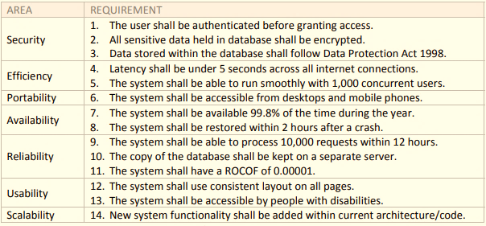

**CHAPTER 3**

# **ARCHITECTURAL STYLES**

## “Service oriented architecture” of Bank Management System

**DEFINTION**

A service is software and hardware independent, stand‐alone, scalable, reusable, self‐contained, distributed, loosely coupled and standardised solution delivering a particular functionality. A service is made‐up ofservice implementation and service interface, and can consist of other services.

Service-Oriented Architecture or SOA is an architectural approach for designing and developing a [web application](https://www.decipherzone.com/blog-detail/The-process-of-web-application-development). In this approach, an application uses services available over the network via communication calls or requests.

SOA includes a set of design principles that structure system development while providing means for integrating components into a unified and decentralized [architecture](https://www.decipherzone.com/blog-detail/benefits-microservices-architecture).

It allows developers to merge a considerable amount of facilities from existing services to the application.

In [SOA](https://www.infoworld.com/article/2071889/what-is-service-oriented-architecture.html), resources are packages as “services”, that are self-contained and well-defined modules that offer standard business functionality and are independent of the context or state of other services.

### “Layered architecture” of Bank Management System

There are five layers in layered architecture:

* User interaction layer
* Functionality layer
* Business rules layer
* Application core layer
* Database layer

**User Interaction layer**

The menus and buttons used for create account, transactions & every other action performing through clicking held in this layer. It is the most visible layer of the application we are displaying.

**Functionality layer**

In this layer the functions of a system performed like we check the activity of login, transactions held by user, balance inquiry, and all the functions perform in this layer.

**Business rule layer**

The business rule of banking system is security & availability. In this we assure that our system is secure & safe and all the requirements are available 24/7.

**Application layer**

All the codes are there in this layer. The code that we used to implement this system is in application layer.

**Database layer**In this layer all the transactions, balance inquiries and all the functions that are performing will update, delete, & retrieve.

#### Conclusions

Having reviewed each architectural style it became apparent that the two most suitable styles for this project are Service‐Oriented and Object‐Oriented. These two styles match majority of the client requirements as well as being widely‐used approaches today, indicating that the deployed system will be futureproof. Being so popular presently, the maintenance of the system will be carried‐out easily by the most software engineers.

The layered architectural style was abandoned due to weak performance. As mentioned earlier, the layered approach requires more time to process data when compared to SOA and OO. The component‐based architectural style will be taken forward and implemented as a SOA. The OO architectural style was chosen because it is easily scalable due to polymorphism, reusable due to inheritance and fully testable using most available techniques. Similarly, SOA is scalable, reusable, loosely coupled and independent making it an ideal competitor to OO. Both architectural styles bring more advantages to the projects than disadvantages, making them ideal solutions to the problem.

**CHAPTER 4**

# **UML MODELING**

## USE CASE DIAGRAM

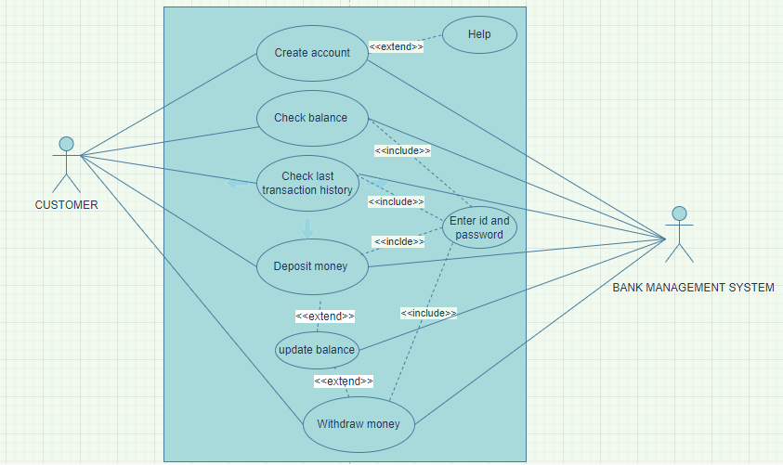

**DESCRIPTION**

The relationship between actors & use cases are:

**Customer**

It includes:

* Create account
* Check balance
* Deposit money
* Withdraw money
* View Transaction History
* Help

**Bank**

It includes:

* Create account
* Check balance
* Enter id and password
* Deposit money
* Update balance
* Withdraw money
* View Transaction History

ACTIVITY DIAGRAM

**ACTIVITY DIAGRAM FOR CREATE ACCOUNT**

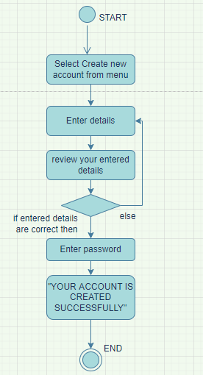

**DESCRIPTION OF CREATE ACCOUNT**

In this customer need to enter all his credentials in order to create account and after that he/she rechecks his credentials that either they are correct if they are correct then he must submit it and hence his account will be created. And the process will terminate.

**ACTIVITY DIAGRAM FOR DEPOSIT /WITHDRAW MONEY**

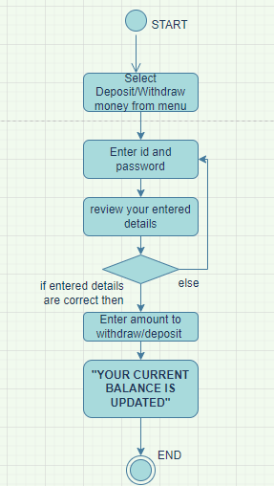

**DESCRIPTION OF DEPOSIT/ WITHDRAW MONEY**

For this customer need to enter all his credentials in order to fist login to his account and after that he/she can deposit /withdraw money. If he/she has entered the correct password then he can deposit/withdraw money and then his updated balance will be displayed on screen . And the process will terminate.

**ACTIVITY DIAGRAM FOR CHECK BALANCE**

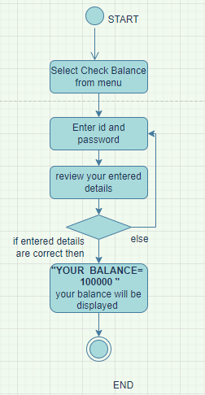

**DESCRIPTION OF CHECK BALANCE**

For this customer need to enter all his credentials in order to fist login to his account and after that he/she can check balance. If he/she has entered the correct password then his account statement would be displayed. And the process will terminate.

**ACTIVITY DIAGRAM FOR TRANSACTION HISTORY**

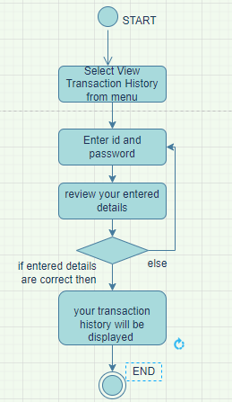

**DESCRIPTION OF VIEW TRANSACTION HISTORY**

For this customer need to enter all his credentials in order to fist login to his account and after that he/she can view transaction history. If he/she has entered the correct password then his transaction history would be displayed. And the process will terminate.

#### CLASS DIAGRAM

**CLASS DIAGRAM**

|  |
| --- |
| DESCRIPTION |
| Classes |
| Bank , customer , account |
| Attributes |
| Customer - name, id, cnic, phone no, account_type, balance, city  Bank- name,no_of_customers  Account -number, balance, type |
| Methods |
| Customer- check_balance, create account, deposit money, withdraw money, view_transaction_history and ask_for_help  Bank- update_balance and give_help  Account- saving(rate_of_interest), current(calculate_interest) |
| Inheritance/Generalization |
| Account- saving,current |
| Aggregation |
| Account- Bank |
| Association |
| Customer- Account |

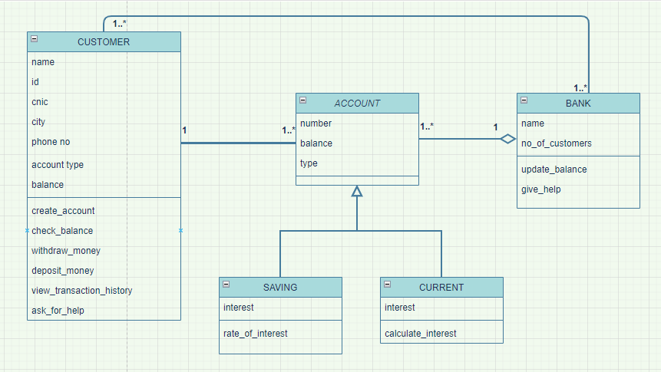

**DESCRIPTION**

**Classes**

* BANK

Bank class has attributes name,no_of_customers and member functions update_balance and give_help.

* CUSTOMER

Customer class has attributes name, id , cnic , phone no , account_type ,balance ,city and member functions check_balance, create account, deposit money, withdraw money , view_transaction_history and ask_for_help.

* ACCOUNT

1. SAVING
2. CURRENT

Account class has attributes number, balance, type. Account is a generalized class having two subclasses having and current.

**SEQUENCE DIAGRAM**

**SEQUENCE DIAGRAM**

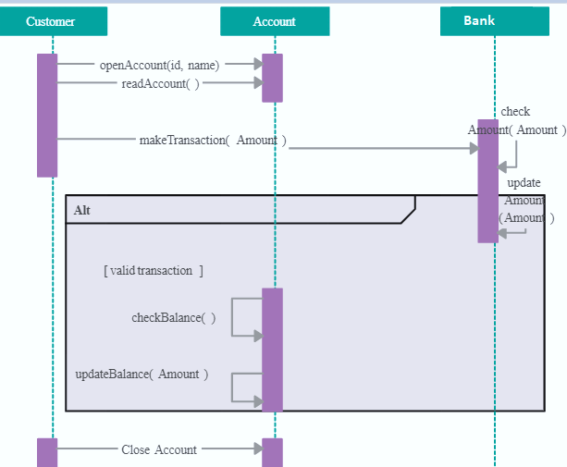

**SEQUENCE DIAGRAM FOR BANK MANAGEMENT SYSTEM**

**CHAPTER 5**

# **SDA PRINCIPLES**

## SDA principles

The following are the SDA principles:

* Problem partitioning
* Abstraction
* Modularity
* Top down & bottom up strategy

### Problem partitioning

All the problems can be solved at a time but it is difficult to solve all the problems so we divide it into smaller portion like a lot of transactions are being held at one time it is difficult to see whole data at a time so we break it into smaller chunks so that we can easily see & find our required transaction.

These chunks are not independent to each other as they are part of one whole system.

**Benefits of problem partitioning**

* Software is easy to understand
* Software becomes simple
* Software is easy to test
* Software is easy to modify
* Software is easy to maintain
* Software is easy to expand

#### ABSTRACTION

Abstraction is process of hiding certain details and showing only essential information to user. For example, in banking system user will only see their own transactions and balance but the CEO or the bank management system will see all the details of every account. So only essential data that the user want to see is provided to user and hide other details.

**Functional Abstraction**

In functional abstraction, details of the algorithms to accomplish the function are not visible to the consumer of the function. For example, the system and user perform their own functions in banking management system but admin see the details of the user but user only see their details not system.

**Data Abstraction**

Data abstraction refers to providing only essential information about the data to the outside world, hiding the background details or implementation. For example, we only provide the details of user to it not all the details that are performing in backend.

##### **MODULARITY**

Modularity specifies to the division of software into separate modules which are differently named and addressed and are integrated later on in to obtain the completely functional software. It is the only property that allows a program to be intellectually manageable. Single large programs are difficult to understand and read due to a large number of reference variables, control paths, global variables, etc.

For example, the system is BANK MANAGEMENT SYSTEM. The modules are:

* Create account
* Check balance
* Withdraw money
* Deposit money
* View transaction history

###### **Top Down & Bottom Up strategy**

**Top down**

This approach starts with the identification of the main components and then decomposing them into their more detailed sub-components.

For example, account is decomposed into saving account &current account etc.

**Bottom up**

A bottom-up approach begins with the lower details and moves towards up the hierarchy. For example, saving account & current account are the subclasses of class account.

**CHAPTER 6**

# **IMPLEMENTATION**

# **CODE**

**SOFTWARE USED**

**ONLINE COMPILER**

[**https://www.programiz.com/java-programming/online-compiler/**](https://www.programiz.com/java-programming/online-compiler/)

**CODE IN JAVA**

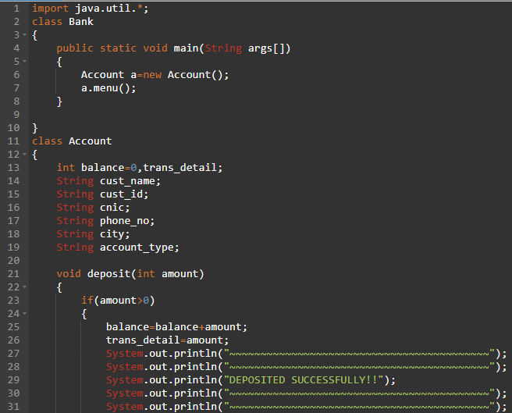

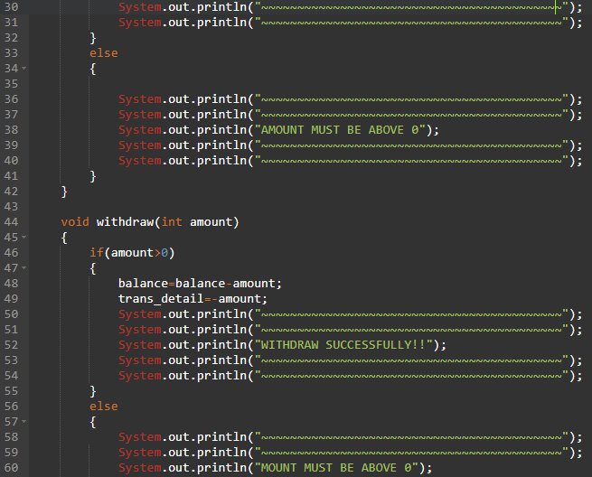

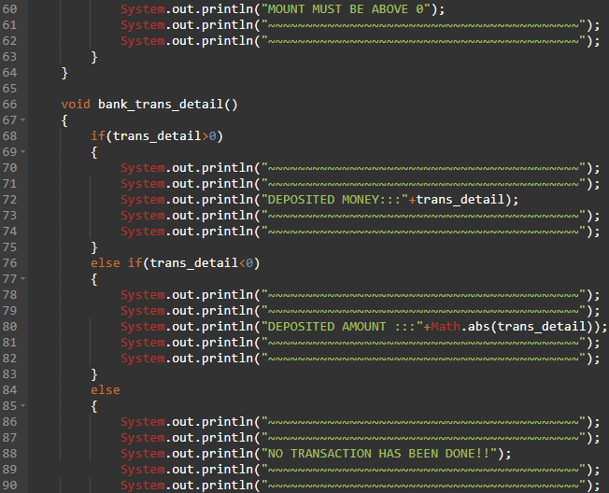

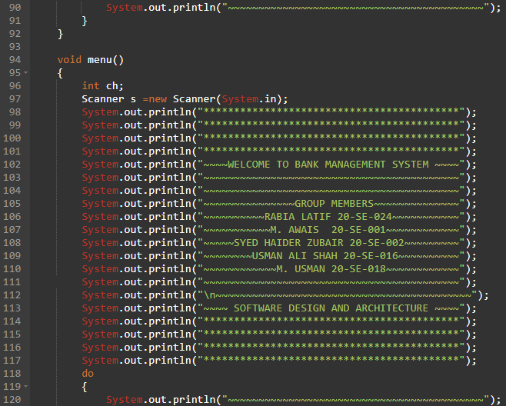

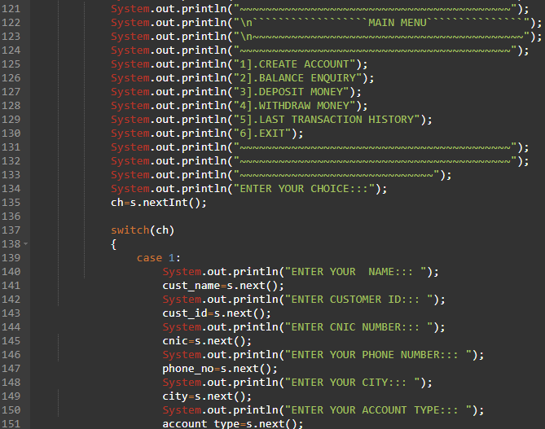

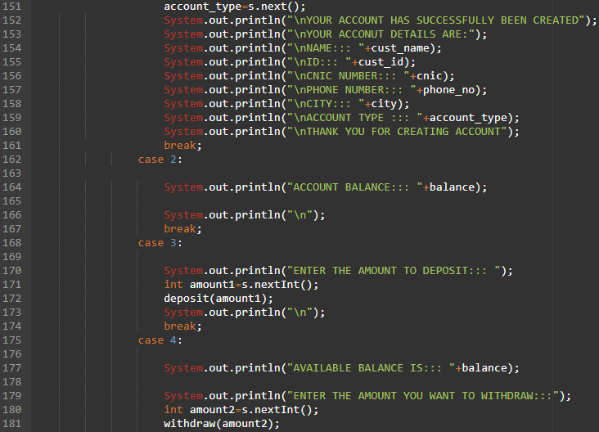

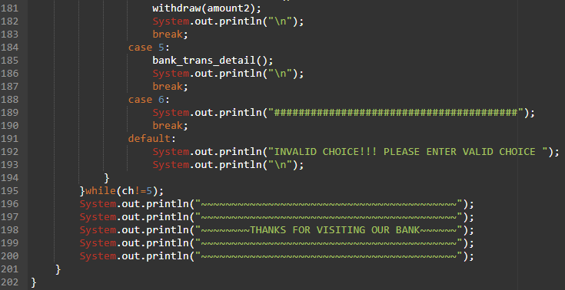

**INPUT**

|  |
| --- |
| import java.util.*;  class Bank  {  public static void main(String args[])  {  Account a=new Account();  a.menu();  }  }  class Account  {  int balance=0,trans_detail;  String cust_name;  String cust_id;  String cnic;  String phone_no;  String city;  String account_type;    void deposit(int amount)  {  if(amount>0)  {  balance=balance+amount;  trans_detail=amount;  System.out.println("~~~~~~~~~~~~~~~~~~~~~~~~~~~~~~~~~~~~~~~~~~");  System.out.println("~~~~~~~~~~~~~~~~~~~~~~~~~~~~~~~~~~~~~~~~~~");  System.out.println("DEPOSITED SUCCESSFULLY!!");  System.out.println("~~~~~~~~~~~~~~~~~~~~~~~~~~~~~~~~~~~~~~~~~~");  System.out.println("~~~~~~~~~~~~~~~~~~~~~~~~~~~~~~~~~~~~~~~~~~");  }  else  {    System.out.println("~~~~~~~~~~~~~~~~~~~~~~~~~~~~~~~~~~~~~~~~~~");  System.out.println("~~~~~~~~~~~~~~~~~~~~~~~~~~~~~~~~~~~~~~~~~~");  System.out.println("AMOUNT MUST BE ABOVE 0");  System.out.println("~~~~~~~~~~~~~~~~~~~~~~~~~~~~~~~~~~~~~~~~~~");  System.out.println("~~~~~~~~~~~~~~~~~~~~~~~~~~~~~~~~~~~~~~~~~~");  }  }    void withdraw(int amount)  {  if(amount>0)  {  balance=balance-amount;  trans_detail=-amount;  System.out.println("~~~~~~~~~~~~~~~~~~~~~~~~~~~~~~~~~~~~~~~~~~");  System.out.println("~~~~~~~~~~~~~~~~~~~~~~~~~~~~~~~~~~~~~~~~~~");  System.out.println("WITHDRAW SUCCESSFULLY!!");  System.out.println("~~~~~~~~~~~~~~~~~~~~~~~~~~~~~~~~~~~~~~~~~~");  System.out.println("~~~~~~~~~~~~~~~~~~~~~~~~~~~~~~~~~~~~~~~~~~");  }  else  {  System.out.println("~~~~~~~~~~~~~~~~~~~~~~~~~~~~~~~~~~~~~~~~~~");  System.out.println("~~~~~~~~~~~~~~~~~~~~~~~~~~~~~~~~~~~~~~~~~~");  System.out.println("MOUNT MUST BE ABOVE 0");  System.out.println("~~~~~~~~~~~~~~~~~~~~~~~~~~~~~~~~~~~~~~~~~~");  System.out.println("~~~~~~~~~~~~~~~~~~~~~~~~~~~~~~~~~~~~~~~~~~");  }  }    void bank_trans_detail()  {  if(trans_detail>0)  {  System.out.println("~~~~~~~~~~~~~~~~~~~~~~~~~~~~~~~~~~~~~~~~~~");  System.out.println("~~~~~~~~~~~~~~~~~~~~~~~~~~~~~~~~~~~~~~~~~~");  System.out.println("DEPOSITED MONEY:::"+trans_detail);  System.out.println("~~~~~~~~~~~~~~~~~~~~~~~~~~~~~~~~~~~~~~~~~~");  System.out.println("~~~~~~~~~~~~~~~~~~~~~~~~~~~~~~~~~~~~~~~~~~");  }  else if(trans_detail<0)  {  System.out.println("~~~~~~~~~~~~~~~~~~~~~~~~~~~~~~~~~~~~~~~~~~");  System.out.println("~~~~~~~~~~~~~~~~~~~~~~~~~~~~~~~~~~~~~~~~~~");  System.out.println("DEPOSITED AMOUNT :::"+Math.abs(trans_detail));  System.out.println("~~~~~~~~~~~~~~~~~~~~~~~~~~~~~~~~~~~~~~~~~~");  System.out.println("~~~~~~~~~~~~~~~~~~~~~~~~~~~~~~~~~~~~~~~~~~");  }  else  {  System.out.println("~~~~~~~~~~~~~~~~~~~~~~~~~~~~~~~~~~~~~~~~~~");  System.out.println("~~~~~~~~~~~~~~~~~~~~~~~~~~~~~~~~~~~~~~~~~~");  System.out.println("NO TRANSACTION HAS BEEN DONE!!");  System.out.println("~~~~~~~~~~~~~~~~~~~~~~~~~~~~~~~~~~~~~~~~~~");  System.out.println("~~~~~~~~~~~~~~~~~~~~~~~~~~~~~~~~~~~~~~~~~~");  }  }  void menu()  {  int ch;  Scanner s =new Scanner(System.in);  System.out.println("******************************************");  System.out.println("******************************************");  System.out.println("******************************************");  System.out.println("******************************************");  System.out.println("~~~~WELCOME TO BANK MANAGEMENT SYSTEM ~~~~");  System.out.println("~~~~~~~~~~~~~~~~~~~~~~~~~~~~~~~~~~~~~~~~~~");  System.out.println("~~~~~~~~~~~~~~~~~~~~~~~~~~~~~~~~~~~~~~~~~~");  System.out.println("~~~~~~~~~~~~~~~GROUP MEMBERS~~~~~~~~~~~~~~");  System.out.println("~~~~~~~~~~RABIA LATIF 20-SE-024~~~~~~~~~~~");  System.out.println("~~~~~~~~~~~M. AWAIS 20-SE-001~~~~~~~~~~~~");  System.out.println("~~~~~SYED HAIDER ZUBAIR 20-SE-002~~~~~~~~~");  System.out.println("~~~~~~~~USMAN ALI SHAH 20-SE-016~~~~~~~~~~");  System.out.println("~~~~~~~~~~~~M. USMAN 20-SE-018~~~~~~~~~~~~");  System.out.println("~~~~~~~~~~~~~~~~~~~~~~~~~~~~~~~~~~~~~~~~~~");  System.out.println("\n~~~~~~~~~~~~~~~~~~~~~~~~~~~~~~~~~~~~~~~~~~");  System.out.println("~~~~ SOFTWARE DESIGN AND ARCHITECTURE ~~~~");  System.out.println("******************************************");  System.out.println("******************************************");  System.out.println("******************************************");  System.out.println("******************************************");  do  {  System.out.println("~~~~~~~~~~~~~~~~~~~~~~~~~~~~~~~~~~~~~~~~~~");  System.out.println("~~~~~~~~~~~~~~~~~~~~~~~~~~~~~~~~~~~~~~~~~~");  System.out.println("\n``````````````````MAIN MENU```````````````");  System.out.println("\n~~~~~~~~~~~~~~~~~~~~~~~~~~~~~~~~~~~~~~~~~~");  System.out.println("~~~~~~~~~~~~~~~~~~~~~~~~~~~~~~~~~~~~~~~~~~");  System.out.println("1].CREATE ACCOUNT");  System.out.println("2].BALANCE ENQUIRY");  System.out.println("3].DEPOSIT MONEY");  System.out.println("4].WITHDRAW MONEY");  System.out.println("5].LAST TRANSACTION HISTORY");  System.out.println("6].EXIT");  System.out.println("~~~~~~~~~~~~~~~~~~~~~~~~~~~~~~~~~~~~~~~~~~");  System.out.println("~~~~~~~~~~~~~~~~~~~~~~~~~~~~~~~~~~~~~~~~~~");  System.out.println("~~~~~~~~~~~~~~~~~~~~~~~~~~~~~~");  System.out.println("ENTER YOUR CHOICE:::");  ch=s.nextInt();    switch(ch)  {  case 1:  System.out.println("ENTER YOUR NAME::: ");  cust_name=s.next();  System.out.println("ENTER CUSTOMER ID::: ");  cust_id=s.next();  System.out.println("ENTER CNIC NUMBER::: ");  cnic=s.next();  System.out.println("ENTER YOUR PHONE NUMBER::: ");  phone_no=s.next();  System.out.println("ENTER YOUR CITY::: ");  city=s.next();  System.out.println("ENTER YOUR ACCOUNT TYPE::: ");  account_type=s.next();  System.out.println("\nYOUR ACCOUNT HAS SUCCESSFULLY BEEN CREATED");  System.out.println("\nYOUR ACCONUT DETAILS ARE:");  System.out.println("\nNAME::: "+cust_name);  System.out.println("\nID::: "+cust_id);  System.out.println("\nCNIC NUMBER::: "+cnic);  System.out.println("\nPHONE NUMBER::: "+phone_no);  System.out.println("\nCITY::: "+city);  System.out.println("\nACCOUNT TYPE ::: "+account_type);  System.out.println("\nTHANK YOU FOR CREATING ACCOUNT");  break;  case 2:    System.out.println("ACCOUNT BALANCE::: "+balance);    System.out.println("\n");  break;  case 3:    System.out.println("ENTER THE AMOUNT TO DEPOSIT::: ");  int amount1=s.nextInt();  deposit(amount1);  System.out.println("\n");  break;  case 4:    System.out.println("AVAILABLE BALANCE IS::: "+balance);    System.out.println("ENTER THE AMOUNT YOU WANT TO WITHDRAW:::");  int amount2=s.nextInt();  withdraw(amount2);  System.out.println("\n");  break;  case 5:    System.out.println("YOUR TRANSACTION HISTORY IS:::");  bank_trans_detail();  System.out.println("\n");  break;  case 6:  System.out.println("########################################");  break;  default:  System.out.println("INVALID CHOICE!!! PLEASE ENTER VALID CHOICE ");  System.out.println("\n");  }  }while(ch!=5);  System.out.println("~~~~~~~~~~~~~~~~~~~~~~~~~~~~~~~~~~~~~~~~~~");  System.out.println("~~~~~~~~~~~~~~~~~~~~~~~~~~~~~~~~~~~~~~~~~~");  System.out.println("~~~~~~~~THANKS FOR VISITING OUR BANK~~~~~~");  System.out.println("~~~~~~~~~~~~~~~~~~~~~~~~~~~~~~~~~~~~~~~~~~");  System.out.println("~~~~~~~~~~~~~~~~~~~~~~~~~~~~~~~~~~~~~~~~~~");  }  } |

**OUTPUT OF THE CODE**

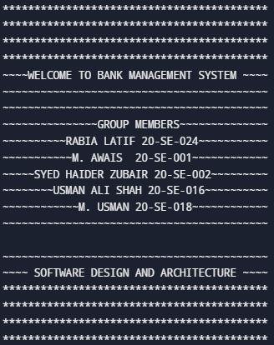

**MAIN MENU**

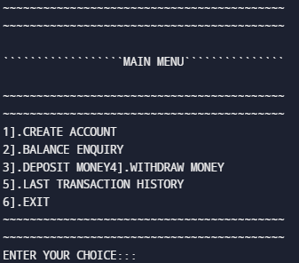

**CREATE ACCOUNT**

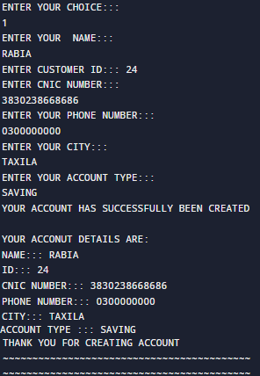

**BALANCE ENQUIRY**



**DEPOSIT MONEY**

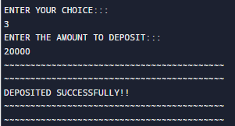

**WITHDRAW MONEY**

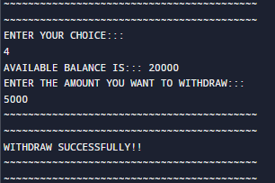

**VIEW TRANSACTION HISTORY**

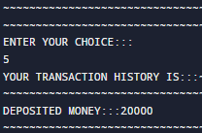

**EXIT**



**DEFAULT SWITCH CASE**

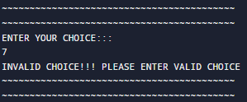



**CONCLUSIONS**

**CHAPTER 7**

## CONCLUSIONS

This project has been designed using the principles of **OOP, SE, SRE, PF and SDA.**

The major programming concepts used in this project are:

* Classes
* Objects
* Functions
* Encapsulation
* Abstraction
* Inheritance
* Switch case statements
* Conditional statements
* Loops

### REFRENCES

* [www.w3schools.com/java/java_abstract.asp](http://www.w3schools.com/java/java_abstract.asp)
* [www.javatpoint.com/software-engineering-software-design-principles](http://www.javatpoint.com/software-engineering-software-design-principles)
* [www.freeprojectz.com/uml-diagram/internet-banking-system-uml-diagram](http://www.freeprojectz.com/uml-diagram/internet-banking-system-uml-diagram)
* [www.dbforums.com](http://www.dbforums.com)
* [www.ibm.com](http://www.ibm.com)
* Chihi, H., Chainbi, W., Ghdira, K. (2016) ‘Cloud computing architecture and migration strategy for universities and higher education’, Proceedings of IEEE/ACS International Conference on Computer Systems and Applications, vol.2016‐. DOI: 10.1109/AICCSA.2015.7507140.
* Crotty, J., Horrocks, I. (2017) ‘Managing legacy system costs: A case study of a meta‐assessment model to identify solutions in a large financial services company’, Applied Computing and Informatics, 13(2), pp.175‐183. DOI: 10.1016/j.aci.2016.12.001.

# **GLOSSARY**

## TERMS TO UNDERSTAND

|  |  |
| --- | --- |
| TERM | DEFINITION |
| Class | a blueprint of data member and functions or we can say a template which has attributes and functions |
| Object | Instance of class |
| Abstraction | used to hide background details or any unnecessary implementation about the data so that users only see the required information |
| Inheritance | the process by which genetic information is passed on from parent to child i.e, from base class to derived class |
| Association | a “using” relationship between two or more objects in which the objects have their own lifetime and there is no owner |
| Generalization | the technique of extracting the essential characteristics (these include attributes, properties and methods) from two or more subclasses and then combining them inside a generalized base class (also called a superclass) |
| Aggregation | a relation that exists between two or more two objects which individually have their own individual life cycle along with the ownership |
| Encapsulation | the bundling of data, along with the methods that operate on that data, into a single unit , data hiding |

### ABBREVIATIONS

|  |  |
| --- | --- |
| ABBREVIATION | STANDS FOR |
| OOP | OBJECT ORIENTED PROGRAMMING |
| SDA | SOFTWARE DESIGN ND ARCHITECTURE |
| PF | PROGRAMMING FUNDAMENTALS |
| SRE | SOFTWARE REQUIREMENT ENGINEERING |
| SE | SOFTWARE ENGINEERING |

**\*\*\*\*\*\*\*\*\*\*\*\*\*\*\*\*\*\*\*\*\*\*\*\*\*\*\*\*\*\*\*\*\*\***